x

**Edzell Health Centre Newsletter**

**Autumn 2023 Edition (September - November)**

Welcome to our newsletter. The aim of the of our newsletter is to keep the community up to date with current guidance and health related events our community can become involved in. If there is a particular topic area or information you would like to see in our next newsletter, please pass this onto one of our PPG members or feel free to join our next PPG meeting. Your opinions are important to us.

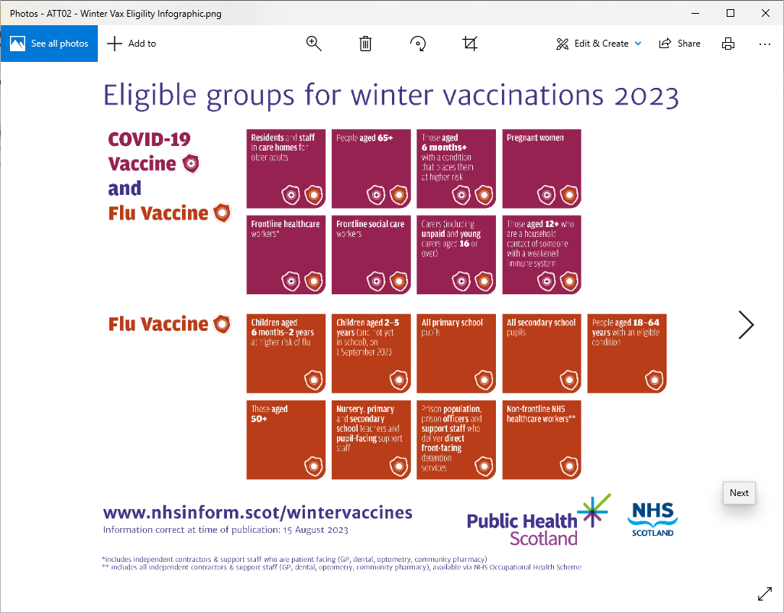

**2023**

**Eligible Groups for**

**Winter Vaccinations**

* **Winter Vaccines will be centralised for 2023.**
* **You will receive an appointent for your Flu/COVID vaccination by email, text or post.**
* **Housebound Patients – Vaccinations will be carried out by District Nurses.**
* **Staff at the Health Centre are unable to arrange appointments or administer vaccines.**

**Vaccination Helpline**

**0800 030 8013**

**Information is available through NHS Inform**

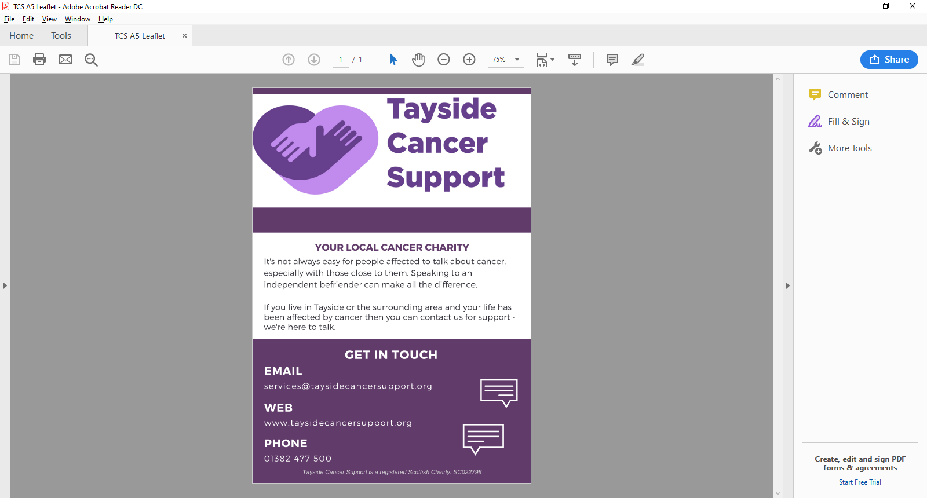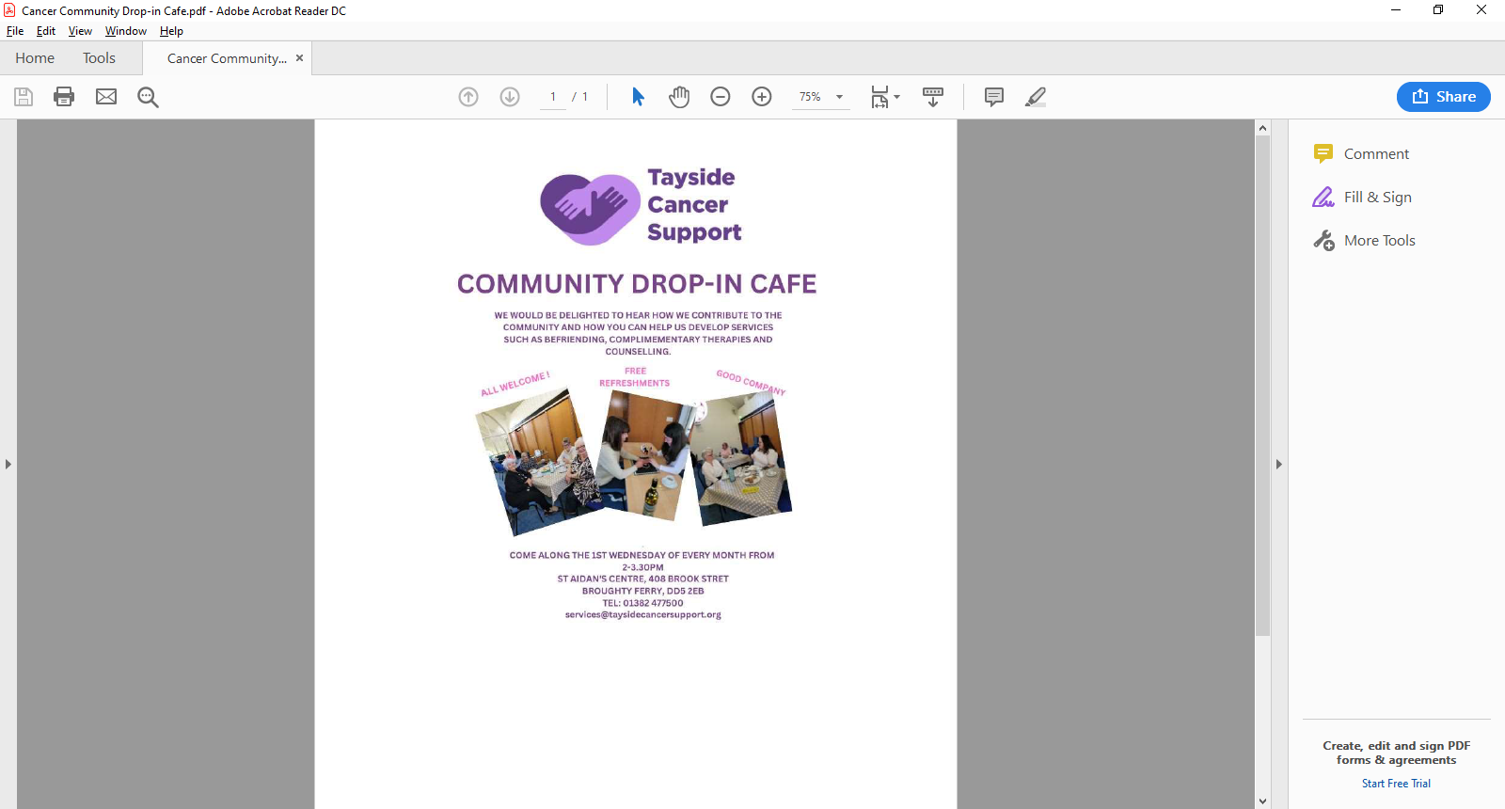

**Mental Health**

**Enhanced Community Support Referral**

This is a new screening hub to manage referrals for patients who need additional support, or specialist care and treatment for their mental health and wellbeing and/or sub stance use.

Referral screening will be delivered in a hub located in Links Health Centre, comprising of staff from Community Mental Health Teams (CMHTs), Angus Integrated Drug and Alcohol Recovery Service (AIDARS), Angus Psychological Therapy Service, and Mental Health and Wellbeing Peer Support

The Community Mental Health Service provides treatment for people with moderate to severe mental health problems. The aim is to encourage and empower people on their personal recovery journey

**A Self Referral Form and Information can be found on our Edzell Health Centre Website.**

**Practice Updates**

**Public Holidays**

The Health Centre will be closed on **Monday 9th October 2023**.

**Appointments**

* All new appointments will be telephone calls initially
* The receptionist will ask for brief details of your call, this enables them to direct

you to the most appropriate service.

* Once telephoned by the doctor you may be asked to attend a face-to-face appointment if required.
* Our phone lines may be busier than usual, so we urge the public to remain patient and remember that your call is important to us. We will get to you as soon as we can.
* **If you feel your reason for calling is an emergency and cannot wait, please hang up and call 999.**

**Edzell Health Centre** High Street**,** Edzell, DD9 7TA **Phone**: 01356 648 209 **Email**: [edzellhealthcentre.tayside@nhs.scot](mailto:edzellhealthcentre.tayside@nhs.scot)

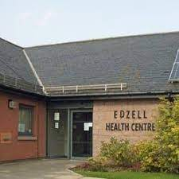

**Pharmacy First Scotland**

* NHS Pharmacy First allows community pharmacy teams to offer advice, treatment or referrals to other healthcare teams where required.
* They can help individuals with conditions such as sore throats, earache, cold sores & common conditions such as urinary tract infections (UTI).
* This helps to ensure people are accessing **the right care in the right place,** without the need to wait to see their GP or attend their local accident & emergency department for non-urgent treatment.

**Pharmacy First Scotland**

* NHS Pharmacy First allows community pharmacy teams to offer advice, treatment or referrals to other healthcare teams where required.
* They can help individuals with conditions such as sore throats, earache, cold sores & common conditions such as urinary tract infections (UTI).
* This helps to ensure people are accessing **the right care in the right place,** without the need to wait to see their GP or attend their local accident & emergency department for non-urgent treatment.